5th GRADE WEEKLY CALENDAR
Mr. McAllister | Room 202
Jan 27th – 31st, 2014
MONDAY | TUESDAY | WEDNESDAY | THURSDAY | FRIDAY
Homework:  History  Finish current event, due tomorrow.  Math  365, L85  Language  Continue reading book report book. Due Feb. 12th.  Other Notes:  MINUMUM DAY  Elementary will pick up at 11:00am | Homework:  Language  Do Think D, pg. 159 in your book.  Math  pg. 366, L86  Science  Read pg. 184-187  If possible, please bring in a glass juice bottle and a hardboiled egg for an experiment we will do on Friday.  Other Notes:  Current event due today  Spelling Test 17 | Homework:  History  Read Pages 158-159  Science  Worksheet 14  Look at the moon tonight (with binoculars if possible) and identify which phase it is in. No need to write it down.  Read pg. 188-191  Other Notes:  Science quiz 18 (7.1-7.2) | Homework:  Language  Think A pg. 162 on notebook paper.  Math  p. 366, L88  History  Skill Sheet 21  Read pg. 159-161  Science  Worksheet 15  Read pg. 193-195  Spelling  Copy list 18 2x & complete "Say it in a sentence" p. 37  Other Notes: | Homework:  History  Read pg. 163-165  Next current event is due this coming Friday, Feb. 7th.  Science  Read pg. 196-198  Spelling  Write 10 sentences using ten words of your choice.  Other Notes:  - Bible verse quiz  - Science quiz 19 (7.3-7.4)  - Language quiz  - History quiz 19  (pg. 157-159, Geography facts 11)  - Logic worksheet due  - Reading vocab quiz  - Packet needs to be signed and returned on Monday. Please return only the tests and quizzes.
Reminders:

Weekly Verse: Titus 3:14
STUDENT SPOTLIGHT!
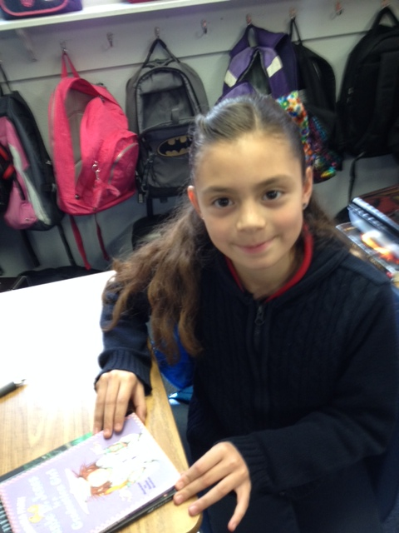
Isis
I have one sister and she is younger than me. I like to go biking. Something funny about me is that my eye moves when I move my mouth. I am ten years old and I live in TJ.

