5th GRADE WEEKLY CALENDAR
Mr. McAllister | Room 202
Nov. 18th – 22nd, 2013
MONDAY | TUESDAY | WEDNESDAY | THURSDAY | FRIDAY
Homework:  Spelling  Copy List 11 twice with defin. Complete "Say It in a Sent." p. 23.  History  Study for test.  CCU 6 section E all and Section F #4-9  Other Notes: | Homework:  Spelling  Copy List 11 - 2x with defin. Complete "Spell It Right!" p. 23  History  Read pgs. 104-105 and 323  Science  Do CCU 4, Sec. D, #3-8, & Sec. E, #11-19  Other Notes:  History Test, Ch. 6 | Homework:  Spelling  Copy List 11 once. Write words missed on trial test - 2x. Study for test  Language  Do "Go Back", p. 101  History  Read pg. 338  Science  CCU 4, Sec C, #13-18 & Sec. F -all. Study Ch. 4 for test.  Other Notes:  Science quiz (sec. 4.4-4.7) | Homework:  Language  Study for Test 5  History  Read pg. 105-110  Science  Read pgs. 124-126  Other Notes:  Language quiz 4  Science test C. 4 | Homework:  Language  Finish the movie poster for your fiction book over the break. Due Dec. 2nd.  History  Read pg. 111-115  Skill Sheet 14  Science  Read pgs. 126-128  Other Notes:  - Bible verse quiz  - Language Test 5  - Logic worksheet due  - Reading vocab quiz  - Packet needs to be signed and returned on Monday. Please return only the tests and quizzes.

Reminders:
Don’t forget we have a class webpage http://www.ovcapatriots.com/fifth-grade.html
School-wide Open House is next week from 6:00-7:30
Friday, November 22nd is OVCA’s Thanksgiving Feast. Please order your meal by Tuesday.
No school next week. Enjoy the break!

Weekly Verse: Genesis 50:19-20

STUDENT SPOTLIGHT!
Sofia!
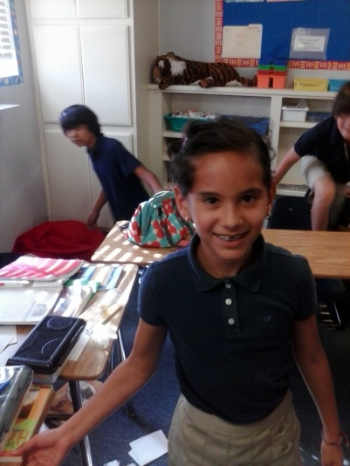
My favorite color is red and my favorite food is shrimp. My favorite thing to do is draw. I like playing with my cousins or making fun things. When I grow up I want to be a dentist.

