5th GRADE WEEKLY CALENDAR
Mr. McAllister | Room 202
Nov. 4th-8th, 2013
MONDAY | TUESDAY | WEDNESDAY | THURSDAY | FRIDAY
Homework:  Math  p. 357 L45  Spelling  Copy List 9 2x. Complete "Say It in a Sentence" pg. 19.  Language  Complete the rough draft of your book report.  History  Read pages 81-86  Science  Read pages 96-98  If you are able, bring a small bag of lima beans and a small, empty margarine or yogurt container with a lid.  Other Notes: | Homework:  Math  p. 358, L46  Spelling  Copy List 9 spelling 2x, vocab once with def. Complete "Proofreading" p. 19  Science  Read pages 98-101.  Try to locate a small piece of brick and bring it by Friday.  Language  Complete the final draft of your book report, the final draft due Tomorrow.  History  Read pg. 86-88.  Other Notes: | Homework:  Spelling  Write words missed on trial test an additional 4x each. Study for Test 9.  History  Do Skill Sheet 13  Read pages 88-90  Science  Read pg. 102-103  Other Notes:  Math quiz 5  Noah Webster book report due today. | Homework:  Math  p. 358, L48  Language  Do Think D, p. 86.  History  Read pages 91-93.  Science  Read pg. 104-105  Other Notes: | Homework:  Penmanship  Pg. 29  History  Read pg. 93-95  Science  Read pgs 106-107.  Other Notes:  - Bible verse quiz  - Science quiz (sections 4.1-4.3)  - History quiz (Pg. 79-90)  - Logic worksheet due  - Reading vocab quiz  - Packet needs to be signed and returned on Monday. Please return only the tests and quizzes.
Reminders:
November 3rd is Daylight Savings (“Fall Back”)
Report cards will be coming out soon. I will be trying to schedule meetings with certain families once I’ve completed the grades.

Weekly Verse: Psalm 77:11-12

STUDENT SPOTLIGHT!
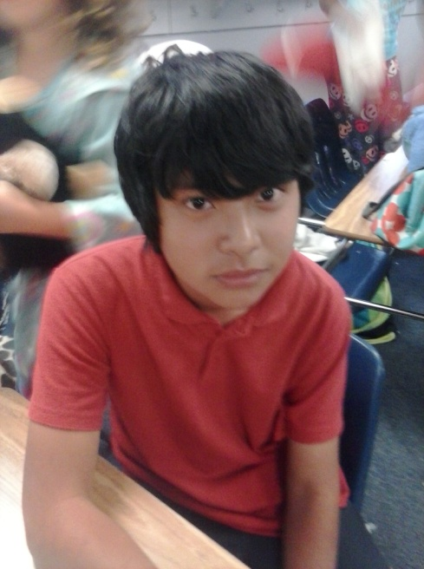
Charles
My favorite sports are football, basketball, and boxing. My favorite football teams are San Francisco and Green Bay. My favorite basketball team is Sacramento. When I grow up I want to become a basketball player. My favorite color is red.

