5th GRADE WEEKLY CALENDAR
Mr. McAllister | Room 202
Dec. 2nd – 6th, 2013
MONDAY | TUESDAY | WEDNESDAY | THURSDAY | FRIDAY
Homework:  Spelling  List 12 - 2x with defin. Complete "Say It in a Sent" pg. 25  History  Read pages 111-115  Science  Read pg. 126-128  Other Notes:  Math Quiz 6 | Homework:  Math  P. 360, L58  Spellin  Copy List 12 - 1x with defin. 1x without. Complete "Super Sentences" pg. 25.  Science  read pg. 129-130  History  Read pgs. 115-117  Other Notes: | Homework:  Spelling  Copy List 12 - 1x. Write words missed on trial test an additional 3x each.  History  read pgs. 117-119  Science  Worksheet 9  Read pg. 130-133  Other Notes:  History quiz 13 (pg. 105-115 & Geography facts 8) | Homework:  Math  pg. 360, L60  Language  Do Think B, pg. 111 (not on separate paper)  History  CCU 7, Sec. C- all, Sec. D #1-7 -- in complete sents.  Science  Do worksheet 10.  Other Notes:  Spelling Test 12 | Homework:  Math  p. 361, L61  History  Study for test over Ch. 7, Sec. B #9-14, and Sec. D #8-9, in complete sentences.  Other Notes:  - Bible verse quiz  - Science Quiz 12 (sections 5.1-5.3)  - Logic worksheet due  - Reading vocab quiz  - Packet needs to be signed and returned on Monday. Please return only the tests and quizzes.

Reminders:
Fiction book movie poster due on Dec. 2nd
School will resume Dec. 2nd

Weekly Verse: Isaiah 40:25-26

STUDENT SPOTLIGHT!
Jordan!
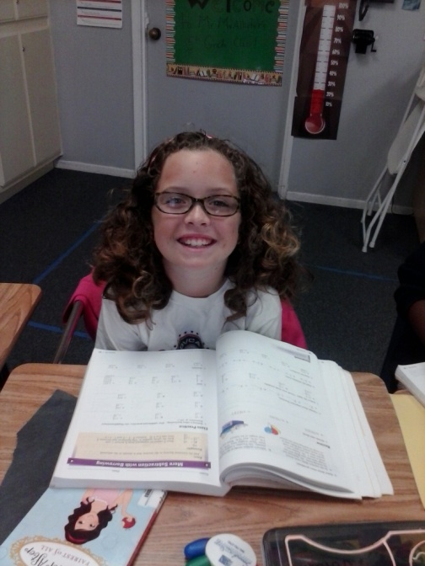
My favorite foods are pizza and ribs. My favorite sport is volleyball. When I grow up I want to be a nurse.
The person who I love the most is my sister Danielle.

Have a great, restful, and happy Thanksgiving!

