5th GRADE WEEKLY CALENDAR
Mr. McAllister | Room 202
Feb. 10th – 13th, 2014
MONDAY | TUESDAY | WEDNESDAY | THURSDAY | FRIDAY
Homework:  Science  Practice your oral report. Be ready for tomorrow.  Math  p.367, L95  History  Current Event due Wednesday  Spelling  Copy missed words on Trial Test 8x.  Other Notes:  Spelling trial test 19  Science Test Chapter 7  History Test (Chapter 10) | Homework:  Math  P. 368 L96  Penmanship  Pg. 36  Other Notes:  Science oral reports due  Language quiz | Homework:  Science  Read pg. 202-205  History  Read pg. 171-173  Other Notes:  Current event due  Math quiz  Shoebox diorama due (for Language) | Homework:  Science  Read pg. 205-210  History  Read pg. 173-175  Spelling  Copy List 20 words 1-25 - 2x, words 26-35- 1x with defin. Complete "Say It in a Sent."  Math  p. 368, L98  Other Notes:  Valentine’s Day Party  - Bible verse quiz  - Language test  - Logic worksheet due  - Reading vocab quiz | Valentine’s Day  No School
Reminders: Open enrollment begins March 3rd. Paying your registration fees before then gives you the chance to win a discount on tuition. Ask the office for more information.
Also, a reminder that elementary students are not allowed to use cell phones or any other electronic devices at school (not even Kindles). Thank you for understanding, please see the Student Handbook for more information on this policy.

Weekly Verse: Luke 1:38

STUDENT SPOTLIGHT!
Ricardo
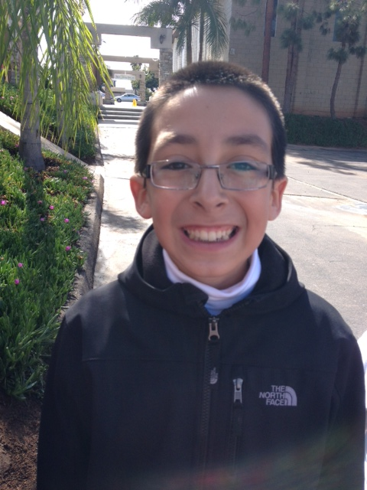
I love playing with my Legos, eating sashimi, the Skylanders, watching Ninjago, and my whole family. I have a younger sister, who’s in third grade here at OVCA. Also, I’m saving money to buy a new videogame.

