5th GRADE WEEKLY CALENDAR
Mr. McAllister | Room 202
March 24th – 28th, 2014
MONDAY | TUESDAY | WEDNESDAY | THURSDAY | FRIDAY
Homework:  Science  Do CCU 9, Sec. D all  Math  p.373 L125  Penmanship  Pg. 42  Spelling  Write list 25 words and defs once. Complete "Say it in a Sentence" pg. 51  Language  Two illustrations due tomorrow.  Other Notes: | Homework:  Science  Do CCU 9 Sec. B-all. Finish worksheet 23  History  Do CCU 13, Sec. E #1-10. Current event due tomorrow.  Spelling  Write list 25 with definitions once.  Complete "Proofreading" pg. 51  Language  Rough draft due tomorrow. They should come to 400-500 words.  Other Notes:  Science quiz (9.6-9.8)  History quiz (Ch.13) | Homework:  Science  Worksheet 24  Do CCU 9 Sec. C- all. Study review guide for test tomorrow.  History  Study the review guide.  Math  L126, pg. 374  Spelling  Write missed words 8x  Other Notes: | Homework:  History  Do CCU 13 Sec. E #11-16. Study review guide.  Language  Second rough draft AND bibliography page are both due tomorrow. They need to be typed.  Other Notes:  Science Test (9-week exam covering Chapters 7-9)  History quiz (climate zones and European geography)  Math quiz  Spelling Test 25 | Minimum Day  Homework:  Math  L128, pg. 374  Language  3 illustrations are due on Monday, as well as the typed Title page.  Final report due on Monday.  Other Notes:  History Test (9-week exam covering Ch. 10-13, Atlas map A6, and Continent Study 3)  - NO Bible verse quiz  - Logic worksheet due  - Reading vocab quiz  - Packet needs to be signed and returned on Monday. Please return only the tests and quizzes.

Reminders:
Friday is a minimum day.

Weekly Verse: NO Bible verse this week. Enjoy the extra study time

STUDENT SPOTLIGHT!
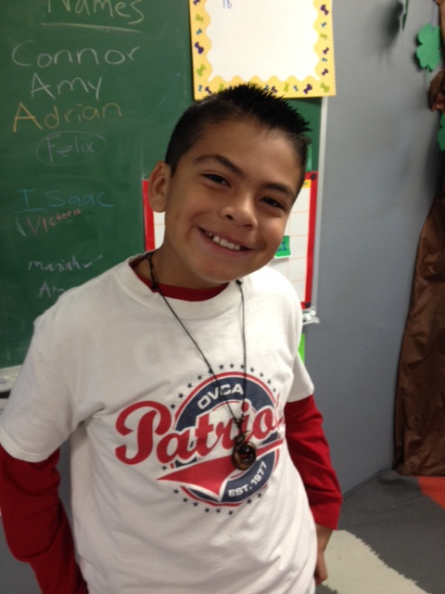
David
I love to play baseball and my favorite position is shortstop. My favorite cartoon is Dragon Ball Z. Not many people seem to know about Dragon Ball Z, but my favorite character is Goku. I really like action figures and video games. I like to chill and hang out with friends. My best friend is named Daniel, and he’s the most loyal, funny, athletic, trustworthy friend you could ever have. Including me there are 4 people in my family. I have two dogs named Simba and Gok (but we call him Papas).

