5th GRADE WEEKLY CALENDAR
Mr. McAllister | Room 202
April 21st - 25th, 2014
MONDAY | TUESDAY | WEDNESDAY | THURSDAY | FRIDAY
Last Day of Spring Break | Homework:  Spelling  Copy List 28 1x w/ defin 1x w/out. Complete "Say It in a Sent."  Health  Read pgs. 34-37. Do CCU 2, Sec. A -all.  History  Do CCU 14, Sec. F #6-9 & Sec. J -all.  Read pg. 249-250  Other Notes:  Language quiz  Oral Book Report due today  (see rubric)  Reminder: If you did not bring a permission slip or money yet, please do so today. Also, if you a parent who is driving the students, please remember to come in an show your drivers license and insurance to the office. Thank you! | Homework:  Math  pg.376, L140  Health  Reread 34-37; CCU 2: A (all)  History  Read pg. 251-254  Penmanship  Pg. 45  Other Notes:  There will be band this day  Health quiz (pg. 24-30) | Homework:  Spelling  Write list 28 once with definitions  Math  pg.376, L141  Other Notes:  Field Trip to Birch Aquarium  Math quiz | Homework:  Spelling  Write missed words from trial test 5 times each  Health  Reread pgs. 37-41. Do CCU 2, Sec. B-D -all.  Quiz Monday  Hisotry  CCU 14: Sec. G (11-15), Sec. I (11-15)  Other Notes:  - Bible verse quiz  - History quiz (pg. 239-249, continent study 3)  - List due for history fair (see letter about history fair)  - Math test  - Language test (units 13 and 14)  - Logic worksheet due  - Reading vocab quiz  - Packet needs to be signed and returned on Monday. Please return only the tests and quizzes.

Reminders:
Because we have the field trip on Tuesday, the Band students will have band on Wednesday.

Weekly Verse: Mark 2:17

STUDENT SPOTLIGHT!
We actually DID have one more student spotlight this year
Victoria

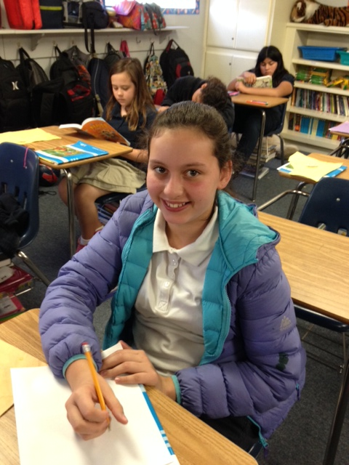
My name is Victoria. I love the color blue. This is my first year at OVCA. I love cake and candy. I am 10 years old. My family is made up of my mom, my brother, my dad, and myself

