5th GRADE WEEKLY CALENDAR
Mr. McAllister | Room 202
June 2-4th , 2014
MONDAY | TUESDAY | WEDNESDAY | THURSDAY | FRIDAY
Homework:  Math  Study for math final. Do some unfinished practive problems in your book that has been challenging for you this year.  Other Notes:  Spelling test 34  (please note, we skipped list 33) | Homework:  History  CCU 16 Section B all  Study for Final  (use the study guide)  Other Notes:  Math final exam  Health final exam | Homework:  None  Other Notes:  History final exam  (Chapters 10-16)  *We will be having a party today after our final exam.  **Elementary awards ceremony at 1:00pm. | First day of Summer
Reminders:
We will be having an “Ice Cream and Guacamole” party on Wednesday after our final exam. The title is an inside joke our class has.
I would like some students to bring some ice cream, chips, and guacamole (or salsa). I also need a pack of plastic spoons. Please email me if you can provide any of these.
Students can also bring a movie to share that day (we might even watch two!). Please make sure it is DVD (not Blu Ray) and rated G or PG.
The students will need their backpacks on Wednesday as well.

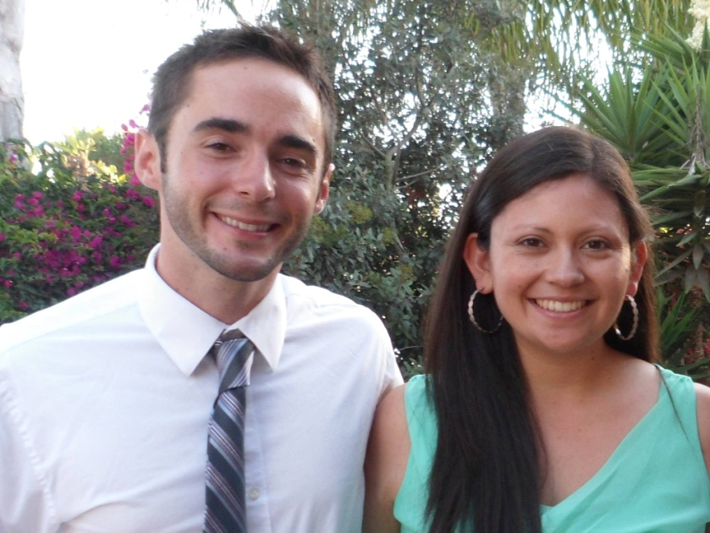
On another note, most of you probably know that my wife and I are moving to Los Angeles this summer, so I will not be here next year. I want to thank you for trusting me with your child and his or her academic learning, social-emotional growth, and discipleship in the Lord Jesus Christ. Each smile, favor, gift, and compliment has meant the world to me. Best of luck in the future and do keep in touch!
Creo que la mayoria de ustedes ya saben, pero mi esposa y yo vamos mudarnos a Los Angeles este verano. Entonces, no voy estar aqui en el año que viene. Quiero agradacerles por la confianza que me han dado en las areas de aprendizaje academico, crecimiento social y emocional, y de ser un dicipulo de Jesus. Cada sonrisa, favor, regalo, y cosa cortés que me han dicho han hecho diferencias grandes para mi. Buena suerte en el futuro y favor de mantenerse en contacto!

Mr. McAllister

