5th GRADE WEEKLY CALENDAR
Mr. McAllister | Room 202
Jan 7th – 10th, 2014
This week I will be on my honeymoon and will have a substitute. I will be back to work on Monday, January 13th. Please refer to students’ planners for the most up-to-date homework, as things are subject to change.
MONDAY | TUESDAY | WEDNESDAY | THURSDAY | FRIDAY
(January 6th)  No school | Homework:  Math  L 73, pg. 363  Penmanship  Pg. 32  Language  Study for test.  On notebook paper, do Think B and Think C on pg. 131  History  Worksheet 17  Other Notes: | Homework:  Spelling  Copy list 15 twice with definitions.  Complete "Say it in a Sentence" pg. 31  Language  Finish reading your Christian fiction book and bring it to class tomorrow.  History  CCU 9, Sec. D, #1-6, in complete sentences.  Other Notes:  Language test | Homework:  Math  p. 363, L75  Spelling  Copy list 15 once with definitions  Complete "Super Sentences" pg. 31  History:  Find and cut out a Current Event article related to your assigned topic. After reading the article several times to become familiar with it, fill out a 4"x6" card with the following info: Your Name, Source of Article, Topic of Article, and 3 Important Facts about Article.  Due Friday, 1/17.  Language  Finish final draft of book report. It will be due, along with the checklist and rough draft (all stapled together) tomorrow.  Science  Re-read pages 156-159  Other Notes:  History quiz (pg. 135-140, Geography facts 10). | Homework:  Math  pg. 364, L76  Spelling  Copy the missed words from List 15 trial test 3 times each.  History  Read pg. 145-149  Science  Read pp. 162-163  Do CCU 6, Sec A -all (on notebook paper)  Other Notes:  - Bible verse quiz  - Logic worksheet due  - Reading vocab quiz  - Packet needs to be signed and returned on Monday. Please return only the tests and quizzes.

Reminders:
This week I will be on my honeymoon and will have a substitute. I will be back to work on Monday, January 13th. Please refer to students’ planners for the most up-to-date homework, as things are subject to change.

Weekly Verse: Psalms 1:1-2

STUDENT SPOTLIGHT!
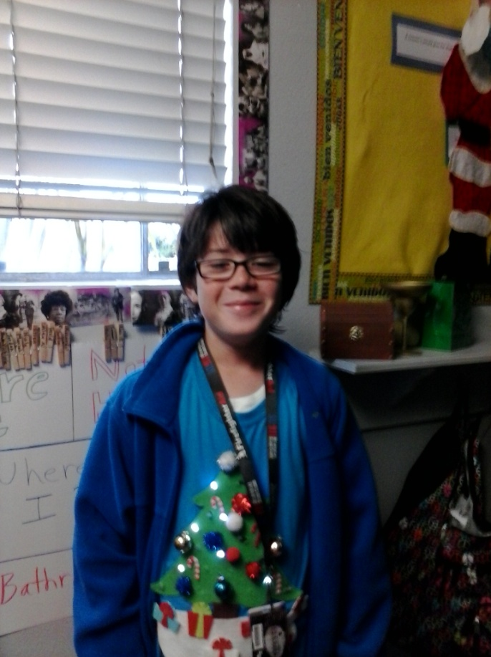
Hello, my name is Connor and my favorite thing to do is play Minecraft. I play tackle football. In football, I play Safety and Punter. I also play basketball. My favorite food is chicken wings. I also like to play baseball with my friends.

