5th GRADE WEEKLY CALENDAR
Mr. McAllister | Room 202
Dec. 16th – 19th, 2013
MONDAY | TUESDAY | WEDNESDAY | THURSDAY | FRIDAY
Homework:  Spelling  (List 14) Copy #1-15 twice, #26-35 once with Definitions  Complete "Say it in a Sentence" p. 29  History  Do CCU 8 Sec. D & E – all  Science  Do CCU5 Sec. A #14-15 & Sec. D -all  Other Notes:  Language quiz on prepositions (memorize them from pg. 115)  History quiz (pg. 121-131, Geography facts 9) | Homework:  Math  L68, p. 362  Spelling  Complete "Spell It Right!"  pg. 29  History  Study for test over Ch. 8. Do CCU 8, Sec. C – all  Science  Do CCU5 Sec. C - all. Study for test - ch. 5  Other Notes:  No band this week | Homework:  Math  Finish any unfinished review work from pg. 126 in order to be ready for tomorrow's test.  Spelling  Write words missed on trial test an additional 10x.  Language  Do Think, pg. 125, #15-25.  Other Notes:  History Test Chapter 8  Science Test Chapter 5 | Homework:  Be reading your Christian fiction book (due Jan. 9th)  Enjoy the break  Other Notes:  - Bible verse quiz  - Spelling test 14  - Math test 7  - Logic worksheet due  - Reading vocab quiz  Packet needs to be signed and returned on Monday. Please return only the tests and quizzes.  No band this week | NO SCHOOL  First day of  Christmas Vacation

Reminders:
Students can bring a Christmas movie to share on Thursday (the 19th)
School will resume on Tuesday, January 7th, 2014.
Weekly Verse: James 3:2

STUDENT SPOTLIGHT!
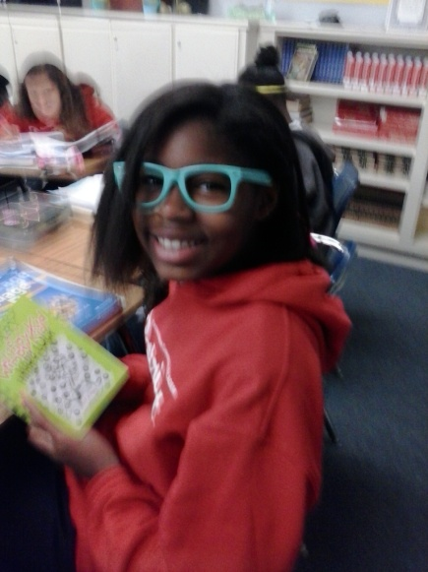

Niala!
I love my dog Coco. I love my mom and dad because if it wasn’t for God I wouldn’t be here. I also have a brother and a nephew named Devin, whom I love. I have a friend in my neighborhood who is awesome named Sarani. My favorite color is sky blue. If I had to pick a favorite football team it would be San Francisco.

I wish you all a very blessed and merry Christmas break and a Happy New Year!!
Que tengan un bendecido y feliz Navidad y un próspero Año Nuevo!!

