5th GRADE WEEKLY CALENDAR
Mr. McAllister | Room 202
Dec. 9th-13th, 2013
MONDAY | TUESDAY | WEDNESDAY | THURSDAY | FRIDAY
Homework:  Language  Pg. 114 Write C:  "Write a biography of someone in your family. Be sure to use adjectives and adverbs correctly when describing that person. “  3 paragraphs minimum.  Spelling  Complete "Say It in a Sent." p. 27  Complete "Proofreading" p.27  History  Read p. 334-335  Science  Read pg. 137-139  Other Notes:  Math test  History Test, Ch. 7 | Homework:  Math  pg. 361, L63  Spelling  Use 15 spelling words in a story. Underline spelling words. Write words not used twice.  History  Read p. 121-124  Science  Read pg. 139-142  Other Notes: | Homework:  Language  Do Remember D, pg. 118.  Spelling  Write the missed words from trial test 2 times each.  History  Read pg. 124-127  Science  Do Science worksheet 11.  Read pg. 142-145  Other Notes: | Homework:  Penmanship  Pg. 31  Math  pg. 361, L65  History  Read pg. 128-131  Science  Read pg. 145-147  Other Notes:  Spelling test 13 | Homework:  Math  L66, p. 362  Language  Copy prepositional list, pg. 115, and practice -for quiz. Write 5 sentences, using at least one prepositional phrase in each.  History  Read pg. 131-133  Science  Study for quiz  Other Notes:  - Bible verse quiz  - Logic worksheet due  - Reading vocab quiz  - Packet needs to be signed and returned on Monday. Please return only the tests and quizzes.

Reminders:

Weekly Verse: Hebrews 11:6

STUDENT SPOTLIGHT!
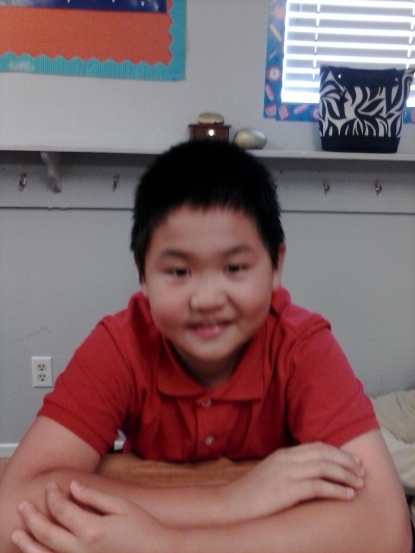
Christian

I love to run and play. One of my favorite sports is soccer. My family is made of 4 people: My mom, my dad, my brother Alan, and of course, myself. I live in an averaged-sized house. I am blessed with many friends. At home I have a dog and a fish.

