5th GRADE WEEKLY CALENDAR
Mr. McAllister | Room 202
Feb.18th – 21st, 2014
MONDAY | TUESDAY | WEDNESDAY | THURSDAY | FRIDAY
No School  President’s Day | Homework:  History  Read pg. 176-177  Spelling  Copy List 20 1x with defin, 1x without. Complete "Super Sentences"  Science  Read pages 211-213  Penmanship  Pg. 37  Other Notes: | Homework:  History  Do CCU 11, Sec. F # 1-7 in complete sentences.  Read pp. 177-180  Math  p. 368, L100  Spelling  Copy missed words 7x.  Science  Read pages 215-217  Other Notes:  History quiz (pg. 171-175, Geog. Fact 12)  Spelling trial test | Homework:  History  Read pp. 180-181. Do CCU 11, Sec. E-all in comp sent.  Math  p. 369, L101  Science  Do CCU 8 Sec. B #1-7.  Read pg. 217-220  Other Notes:  Spelling test | Homework:  History  Do CCU 11, Sec B, #7-12 in complete sentences.  Language  Write a letter to an imaginary pen pal.  Read biography book.  Science  CCU 8, Sec. B. #8-11 on notebook paper.  Read pages 221-222  Other Notes:  - Bible verse quiz  - Math test  - Logic worksheet due  - Reading vocab quiz  - Packet needs to be signed and returned on Monday. Please return only the tests and quizzes.
Reminders:
I would love it if a student could bring in a lamp and some baby powder on Tuesday for an experiment we need to do.
Also, a student may be excused from science homework for Thursday and Friday if he or she completes and brings in the experiment on pg. 214 in the textbook. Please email me if you plan on doing this with your child.
Thanks!
Weekly Verse: Psalm 1:1-2

STUDENT SPOTLIGHT!
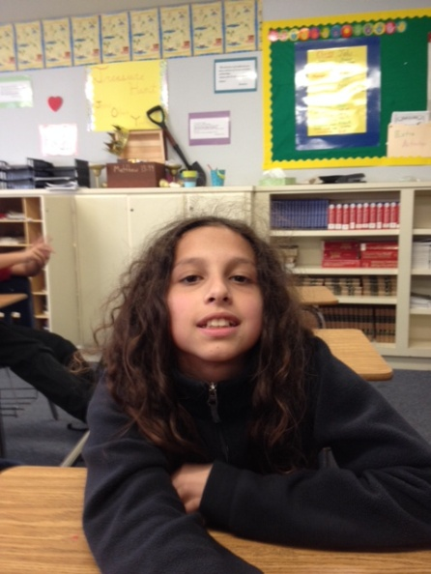
Elisa

I love playful dogs, but I don’t like cats. I also like to play video games. I used to have a hamster named Winkey. I have a dog named Nanny, after Nanny McFee. I also have two brothers.

