5th GRADE WEEKLY CALENDAR
Mr. McAllister | Room 202
March 31st – April 4th, 2014
MONDAY | TUESDAY | WEDNESDAY | THURSDAY | FRIDAY
Homework:  Health  Read pg. 7-10  History  Skill Sheet 26  Penmanship  Pg. 43  Spelling  Write words & defs 2x., list 26  Other Notes: | Homework:  Health  Do the Quick Checkup on pg. 10, #1-6  History  Read pg. 229-231  Math  p.374 L130  Spelling  Do Say it in a Sentence, pg. 53  Language  Start reading a book for an oral book report—Due Thursday, April 17th  Other Notes:  Final illustration and title page due today (typed) | Homework:  Health  Read pg. 16-17  CCU 1, section B, all  History  Read pg. 231-233  Spelling  Write list 26 once, no definitions  Math  p.375 L131  Other Notes:  Entire country report due today  History quiz (pg. 223-228) | Homework:  Health  study for quiz  History  Read pg. 233-236  Spelling  Write list 26 1x and missed words from trial test 10x.  Language  Write down as many synonyms as possible for the following words: enormous, chore, frigid, cook.  Write down a homonym for each of the following words: mail, tale, pail, plain.  Other Notes:  Math test | Homework:  History  CCU 14, Sec. D #1-3 and E #1-4  Math  p.375, L133  Other Notes:  - Health quiz (Ch. 1)  - Bible verse quiz  - Logic worksheet due  - Reading vocab quiz  - Packet needs to be signed and returned on Monday. Please return only the tests and quizzes.

Reminders:
We are now using the Health Book instead of the science book for the rest of the year.

Weekly Verse: Mark 1:17

STUDENT SPOTLIGHT!
Mariah
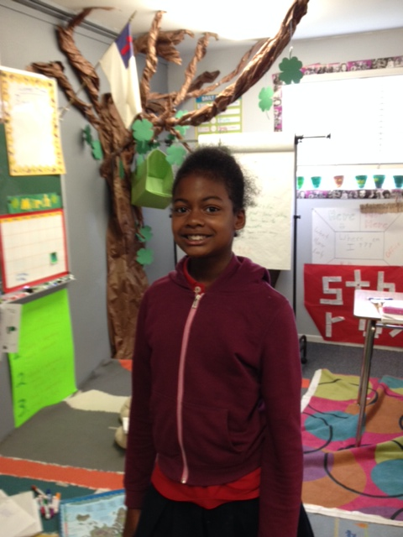
My name is Mariah and my favorite color is pink. My favorite thing to do is sing. I love to draw flowers and music notes. I love sports and cheerleading. OVCA is my favorite school. My favorite animal is a dog. My dog’s name is Chacettha. My favorite subject in school is art and I love glitter.

***Mariah’s spotlight is our last student spotlight of the year. If you have any quotes, jokes, or stories you would like me to include, feel free to let me know.

