5th GRADE WEEKLY CALENDAR
Mr. McAllister | Room 202
May 26th – 30th, 2014
MONDAY | TUESDAY | WEDNESDAY | THURSDAY | FRIDAY
Memorial Day  No School  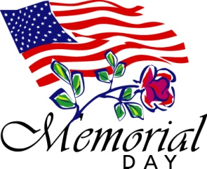 | Homework:  Math  p.381, L163  Spelling  Write missed words from the trial test an additional 5 times each.  Health  read pg. 89-93  Language  Think D pg. 301 and Think D pg. 303  Study for test (see study guide from last week)  History  Read pg. 296-300  study for quiz  Other Notes: | Homework:  History  Read pgs. 303-305. Do CCU 16, Sec. A #9-15.  study for quiz  Health  Read pg. 94-99  Other Notes:  Spelling Test 32  Language final exam  History quiz (pg. 291-300) | Homework:  Math  Pg. 381 L165  History  Study for quiz  Spelling  Copy List 34 once with definitions.  Health  Study for quiz  Other Notes:  History quiz  (pg. 292, 300-307) | Homework:  Math  pg. 382 L166  History  CCU 16, Section A #16 and Section D, all  Health  List armor each Christian should wear and what each piece represents. Study Ch. 1-5 for test on Tuesday.  Spelling  Say it in a sentence, pg. 69  Other Notes:  - Bible verse quiz  - Health quiz  (Chapter 5)  - History quiz  (pg. 302; pg 306; Continent study 3)  - Logic worksheet due  - Packet needs to be signed and returned on Monday. Please return only the tests and quizzes.
Reminders:
Weekly Verse: John 3:17 (last one of the year)

